Design and Simulation of a Narrowband Microstrip Bandstop Filter Using a Modified Square Resonator Geometry
Ayushi Singh¹, Prajanma Srivastava², Yatindra Gaurav³
¹Student in Department of Electronics Engineering, Institute of Engg. And Rural Technology, Prayagraj, India
²Student in Department of Electronics Engineering, Institute of Engg. And Rural Technology, Prayagraj, India
³Head of Department of Electronics Engineering, Institute of Engg. And Rural Technology, Prayagraj, India

Abstract:
The work describes the design and simulation of a Microstrip Narrowband Bandstop Filter using Advanced Design System (ADS) software. The designed filter shows two attenuation notches near 7.6 GHz and 9.5 GHz respectively, with an acceptable insertion loss in the passband region. The response of simulation also shows that the resonator geometry has defined a return loss at 8.9 GHz, thus supporting the fact that the structure is responsible for the required suppression behavior. The filter is implemented on an FR-4 substrate with a dielectric constant of 4.6. Full-wave EM simulations demonstrate good stopband selectivity, stable passband behavior, and a compact physical footprint. The proposed design in suitable for interference mitigation in microwave communication systems that require narrowband rejection.
Keywords:
Narrowband, Microstrip, Bandstop, Square resonator geometry, FR-4 substrate, Interference Mitigation.

- Introduction
In today’s communication era, microwave filters are essential part in electronic and communication systems, as they enable the selection, separation, and control of signals based on frequency [3, 4]. Modern high-speed, high-density wireless communication systems often face issues of interference caused by unwanted signals occupying adjacent or overlapping frequency bands. To mitigate such effects, bandstop filters are employed to reject a specific frequency band while allowing all other frequencies to pass with minimal insertion loss [2, 6]. When the suppressed frequency span is intentionally kept small relative to the overall operating spectrum, such designs are referred as Narrowband Bandstop filters, giving good rejection performance of closely spaced interferes without disturbing adjacent channels [18]
With rapid advancements in wireless technologies, for example, WLAN, Bluetooth, 5G, etc., the demand for the miniaturized filter design that can be easily integrated into RF-frontend modules also increases [5, 20]. Microstrip-based designs are commonly used, as they are lightweight, cost-effective, easily integrable with planar circuitry, and well suited for standard PCBs. A microstrip line is formed by placing a metallic conductor printed on a dielectric substrate with a metal layer located on the bottom surface. It forms a highly practical transmission medium [9]. This geometrical versatility helps designers to ‘tune’ the resonant frequency, notch bandwidths, and coupled characteristics by varying the physical dimensions and/or substrate properties of the particular structure [7, 10].
Different types of resonators, like hairpin, interdigital, and ring structures, have been used in order to optimize the frequency performance of the miniaturized circuit and improve the performance of it [4, 15]. Among the different types of resonators, square topology gives a high degree of coupling, multi-mode resonance, and compactness. It also provides an additional attenuation pole in the stopband without adding any additional components [8].
A notch filter, also known as a bandstop filter, is a type of frequency-selective network that rejects a signal falling under a specific frequency band while allowing very little loss of signal to pass [4, 6]. These filters have become an important part of RF/microwave systems where unwanted frequencies need to be reduced, helping avoid interference and maintain proper signal quality [2, 7]. When the rejected band is intentionally kept narrow relative to the overall operating range, the design is referred as a narrowband bandstop filter. It provides sharp and localized attenuation without having any effect on adjacent communication channels [3]. Narrowband suppression is particularly important in modern wireless environments where system must coexist within tightly packed spectral allocations [19]
In this work, we focus on the design and simulation of a narrowband microstrip bandstop filter using square resonator geometry producing distinct attenuation notches at 7.6 GHz and 9.5 GHz, along with strong in out-reflection resonance at 8.9 GHz. It is implemented on an FR-4 substrate. The objective of this study is to achieve compact, predictable, and cost-effective narrowband interference suppression suitable for a range of microwave communication applications. The design presented in this work evolved from an earlier dual-band stop filter that used E-shaped resonators; its geometry was reconfigured to achieve a focused single-band rejection around the desired frequency [1].
- Design Methodology
2-1- Design Concept
The filter designed in this work has a square-shaped resonator, which will produce a bandstop characteristic. A resonator is used as a rejector of signal by creating an interfering path for all frequencies that are in or near the stopband while allowing all other frequencies to pass through with low loss [4]. Strong electromagnetic coupling and multi-mode resonance capabilities also exist in the design of this square loop. These two mentioned characteristics enable sharp rejection and high spectral selectivity [5, 14].
The stopband frequency and bandwidth of the filter can be efficiently regulated by suitably modifying the ring size, coupling gap and substrate properties, which influence the resonant conditions and coupling coefficients [10]. This configuration provides a compact, planar and easily integrable solution suitable for microwave and wireless communication due to its lightweight nature and compatibility with standard PCB fabrication processes [2, 9].
2-2- Structural Design and Layout Description
The structure of the proposed bandstop filter consists of a square resonator coupled to a 50-Ohm microstrip transmission line, as shown in Figure 1. The resonators are placed close to the feedline to achieve strong Electromagnetic Coupling, which creates a distinct stopband at its resonant frequency while allowing low-loss transmission in the passband. The microstrip contains two ports for input and output interfaces for S-Parameter evaluation.
W1
W2
L7
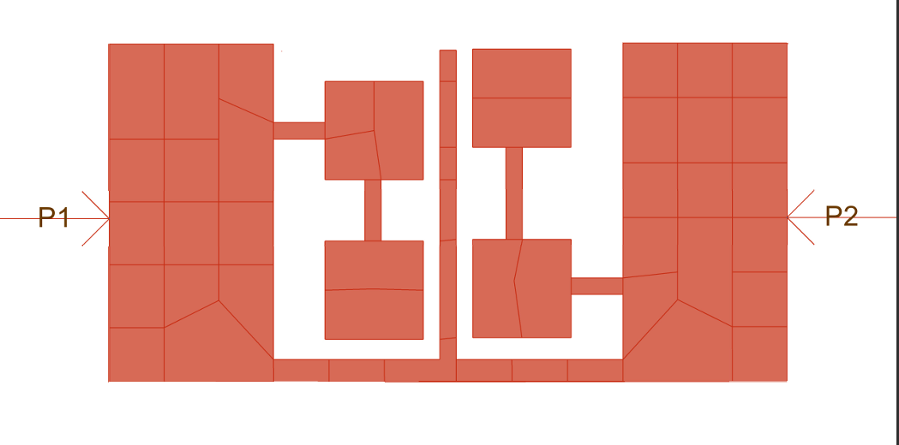
L5
L4
L2
L5
W3
L6
L3
L1
Fig. 1. Layout of Designed Filter

Table 1. Dimensions of the Proposed Filter
Parameters | Dimensions (in mm)
L1 | 3.1
L2 | 3.2
L3 | 2.8
L4 | 0.56
L5 | 0.47
L6 | 0.84
L7 | 0.9
W1 | 1.5
W2 | 0.15
W3 | 0.2

In the layout, each square having the dimensions of 0.9 mm as well as 0.15 mm gap from the resonator. The dimensions of the resonator and coupling gap were optimized through simulation to obtain the desired frequency response and attenuation level [3].
2-3- Substrate Characteristics
The design is implemented on an FR-4 substrate, shown in Figure 2, which consists of a copper conductor layer, and a ground plane. The substrate has a Dielectric constant (ε_{r}) of 4.6, loss tangent (tan δ) of 0.01, with a thickness of 1.6 mm.
FR-4 is preferred for its low cost, mechanical durability, and compatibility with standard PCB fabrication, making it suitable for practical microwave filter implementation [6, 10].
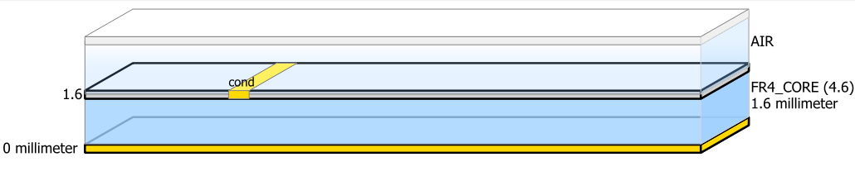
Fig. 2. Substrate of proposed filter

2-4-Design Equation
The resonant behavior of the designed square ring bandstop filter can be roughly related to the fundamental quarter-wavelength resonance condition [3]. The resonant frequency (f₀) of the filter is given by:
(1)
$$f_{0}= \frac{c}{4L_{eff}\sqrt{ε_{eff}}}$$
Where f₀ is the resonant frequency, c is the velocity of the light in free space, L_{eff} is the effective length of the resonator, and ε_{eff} denotes the effective dielectric constant of the substrate.
For analyzing a bandstop filter, its stopband can be described using two key parameters: the center frequency and the fractional bandwidth. The center frequency is defines using the two edges frequencies that mark the points where the attenuation begins to rise. It is given as;
(2)
$$f_{0}= \sqrt{f_{1}f_{2}}$$
To describe how wide the stopband extends relative to this center value, the fractional bandwidth is coming in use. It is written as,
(3)
$$FBW= \frac{f_{2}-f_{1}}{f_{0}}$$
Where f₁ is lower edge frequency and f₂ is the upper edge frequency [18].
2-5- Simulation Setup and Parameters
The proposed bandstop filter was simulated within a frequency range of 0 GHz to 11 GHz to evaluate its performance to observe the reflection and transmission behavior of the design. Several simulation runs were carried out by changing the size of the square ring, the spacing between the resonator and the feed line, and the substrate material. These changes were carried out step by step to ensure the improvisation depth of attenuation in the stopband. All these tested simulations were performed using Advanced Design System (ADS) Software, which is helpful in providing an electromagnetic model of the planar structure and studying the effect of different design parameters [3, 7].

3- Simulated Results and Discussion
3-1-The conclusion
The S-parameter behavior of the proposed filter was evaluated through full-wave electromagnetic simulations to study its frequency response and overall performance. The resulting plots, shown in Figures 3 to 5, present the variation of the filter response across the 0–10 GHz band.
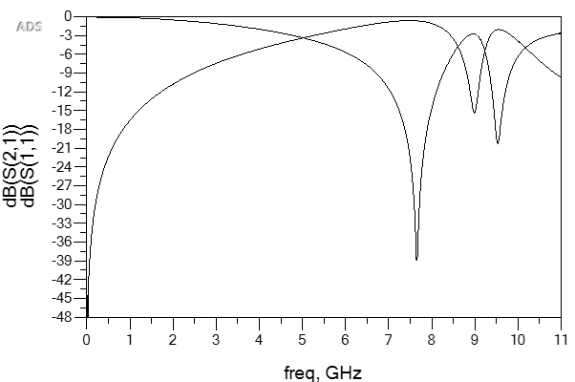
S₂₁
S₁₁
S-PARAMETER (dB)
FREQUENCY (GHz)
Fig. 3. S-Parameter of the filter designed

Figure 3 illustrates the simulated S-parameter results of the proposed bandstop filter using the geometry of square resonator, showing the reflection coefficient S₁₁ and Transmission coefficient S₂₁. The parameter S₁₁ indicates the input return loss, which defines the level of power reflected back toward the source [6]. On the other hand, S₂₁ represents the forward transmission coefficient and provides information about signal propagation [1]. The S₁₁ curve (red) exhibit a notch at around 8.9 GHz, with return losses of 15.3 dB, indicating effective impedance mismatch and strong reflection within these bands. Meanwhile, the S₂₁ curve (blue) shows a significant attenuation notches at 7.6 GHz and 9.5 GHz reaching approximately at 39 dB and 20.2 dB, confirming excellent suppression at the designed stopband frequency [2, 20].
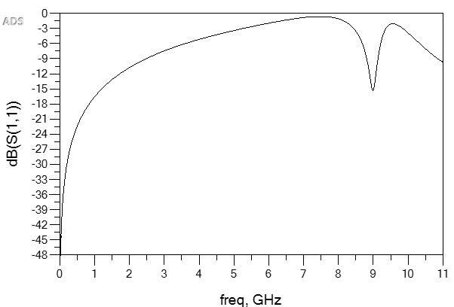
FREQUENCY (GHz)
S-PARAMETER (dB)
S₁₁
Fig. 4. Simulation of Return Loss of the designed filter

Figure 4 depicts the S₁₁ response, represents the input reflection characteristics of the proposed circuit. A clear response appears at 8.9 GHz, where the return loss reaches a pronounced minimum, showing that the resonator absorbs a significant portion of the incident energy at this frequency. This behavior confirms that the structure is strongly excited around the stopband region, with the input impedance aligning closely with the resonant condition of the modified square geometry [8, 14].
Away from this resonance, S₁₁ curve increases toward 0 dB, which is expected in a bandstop configuration because most of the incident power is reflected when the transmission path is suppressed. The overall response is consistent with microstrip resonance theory and coupled-resonator behavior, showing that the structural modifications effectively influence the impedance matching and field confinement within the rejection band [3, 10].
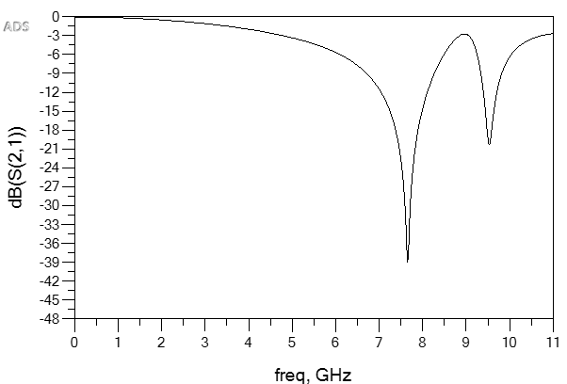
S₂₁
S-PARAMETER (dB)
FREQUENCY (GHz)
Fig. 5. Simulation of Insertion loss characteristics of the designed filter

Figure 5 presents the simulated S₂₁ response, representing the forward transmission coefficient of the proposed bandstop filter. The S₂₁ curve remains nearly flat around 0 dB across the passband frequencies, indicating minimal insertion loss and confirming that the resonator does not disturb frequencies outside the intended rejection region. Two prominent attenuation notches are observed at 7.78 GHz and 9.46 GHz, where the transmission level drops significantly, confirming the presence of a well-defined stopband [2].
The sharp drop in transmission at the resonant frequency shows that the resonator is effectively interacting with the microstrip feed line, leading to strong rejection of the unwanted signal. Outside this region, the passband response remains smooth and stable, indicating that the filter does not disturb the desired frequency range. The clear separation between the attenuation notches further confirms that the resonator-based structure is functioning as intended for narrowband bandstop operation [4].
From the simulated S₂₁ response presented in Figure 5, the designed filter establishes two well-defined stopbands within the higher microwave region. The first notch occurring around at 7.6 GHz, with the 10-dB cutoff frequencies at approx. 6.96 GHz and 8.21 GHz. These points correspond to a stopband width of about 1.25 GHz, giving a Fractional Bandwidth of nearly 16.5%. Such a bandwidth reflects moderate selectivity and indicates that the resonator effectively suppressing energy around its resonance while maintaining stable transmission outside this range.
A second, narrower stopband appears around 9.5 GHz, bounded by 10-dB cutoff frequencies at 9.3 GHz and 9.7 GHz. This produces a much smaller bandwidth of roughly 0.32 GHz and FBW close to 3.3%, highlighting the sharper and more confined nature of this resonance [3].
Together, these characteristics demonstrate that the square-loop configuration can generate multiple controlled rejection bands with strong attenuation and minimal degradation of the surrounding passband [15].
Table 2. Performance parameters of the Designed Filter
S. No. | Parameter | Symbol | Measured value
1 | Centre Frequency | f_{01,} f₀₂ | 7.56 GHz and 9.54 GHz
2 | FBW | FBW_{1,} FBW₂ | 16.5% and 3.35%
3 | Quality Factor | Q₁, Q₂ | 6.05 and 29.8
4 | Maximum Return Loss | S_{11 max} | 15.3 dB
5 | Maximum Insertion Loss | S₂₁ max | 39 dB
6 | Minimum Insertion Loss | S₂₁ min | 0-1 dB in the passband
7 | Substrate Dielectric Constant | εr​ | 4.6
8 | Substrate Thickness | h | 1.6 mm

3-2- Analysis of Design Variations
The dotted response shown in Figure 6, tells us the earlier benchmark design, which has several notches at different frequencies throughout the range, having strong attenuation near 1.8 GHz and 5.2 GHz. The original configuration is well suited for the condition where interference is distributed to multiple frequencies. This distribution offers broader interference mitigation [1].
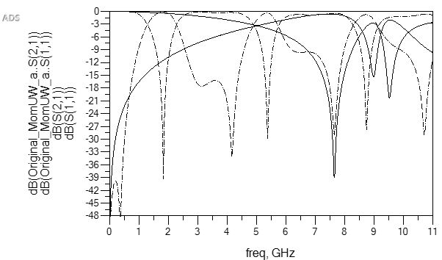
S₂₁
S₁₁
S-PARAMETER (dB)
FREQUENCY (GHz)
Fig. 6. Comparison with Conventional design

In contrast, the solid curve shown in the figure corresponds to the modified square resonator geometry developed in this article shows a more predictable response. The updated structure produces one dominant suppression band around 8.9 GHz which is accompanied by two well-defined impedance notches at approx. 7.6 GHz and 9.5 GHz. This behavior results from the closed-loop current path of the geometry, which decreases parasitic coupling and stabilize the resonant modes.
As a result, the overall passband has become smoother and the rejection band becomes more focused. The revised design is a strong fit for communication systems requiring targeted single-band suppression on standard FR-4 substrates without the cost and fabrication demands of high-permittivity material.
4-The Application
The filter presented in this article demonstrates highly selective behavior, producing good rejection at its designed resonant points. Its main null occurs at 7.6 GHz with an additional attenuation around 9.5 GHz. This dual-notch response enables the circuit to suppress narrow spectral interferers that appear within the upper C-band or the lower portion of the X-band. As a result, the device can support applications such as point-to-point wireless backhaul links specialized receivers that must isolate specific signals to maintain reliable system performance.
As wireless technologies move toward denser frequency allocation in upcoming 5G and pre-6G deployments, compact filtering elements with carefully positioned rejection bands are becoming essential for addressing localized interference sources.
The FR-4 realization of this design provides an economical and fabrication friendly option suited for IoT hardware, automotive sensing platforms, and other RF systems.
5- Conclusion
This study shows the successful design of a narrowband microstrip bandstop filter using a square resonator. This filter generates two frequency bands where the signal was rejected, and the impedance shows consistent resonant behavior within a compact layout. The FR-4 substrate, which is used in this work, shows high frequency rejection, making it suitable for many applications like RF communication modules and radar frontends, as well as microwave systems that require to reject unwanted signals at specific narrowband frequencies on standard PCB circuits.
References
- Anant. Joshi and D. Bhatia, “Design of Compact Dual-Band Bandstop Filter using E-Shaped Resonators,” Proc. IEEE Int. Conf. on Advances in Engineering and Technology Research (ICAETR-2014), Aug. 1-2, 2014.
- K.O. Sahin, A.K. Gorur, and A. Gorur, “Design of a Compact Dual-Band Microstrip Bandstop Filter with High Rejection Levels,” Proc. 2021 13th International Conference on Electrical and Electronics Engineering, Bursa, Turkey, 2021.
- J.S. Hong and M.J. Lancaster, Microstrip Filters for RF/Microwave Applications, New York, NY, USA: Wiley, 2001.
- D. M. Pozar, Microwave Engineering, 4th ed., New York, NY, USA: Wiley, 2012.
- H. Liu, B. Ren, X. Guan, J. Lei, and S. Li, “Compact Dual-Band Bandpass Filter using Quadruple-Mode Square Ring Loaded Resonator,” IEEE Transactions on Microwave Theory and Techniques, vol. 68, no. 5, pp. 1893-1901, May 2020.
- L.B. SenthilMurugan, S.A.A. Raja, S.D. Chakravarthy, and N. Kanniyappan, “Design and Implementation of a Microstrip Band-Stop Filter for Microwave Applications,” Procedia Engineering, vol. 38, pp. 1346-1351, 2012.
- Jia-Sheng Hong, "Microstrip dual-mode band reject filter", IEEE MTT-S Int. Microwave Symp. Dig., vol., no., pp.4, 2005.
- Snyder, R.V.; Sanghoon Shin; , "Bandstop filters using dielectric loaded evanescent mode resonators," Microwave Symposium Digest, IEEE MTT-S International , vol.2, no., pp. 599- 602 Vol.2, 2004.
- T.Edwards, “Foundations for Microstrip Circuit Design.” New York: Wiley- Interscience, 1991.
- R. K. Mongia, I. J. Bahl, P. Bhartia and J. Hong,”RF and microwave coupled-line circuits.” Norwood, MA: Artech House, 2007.
- J. Bonache, I. Gill, J. Garcia-Garcia, and F. Martin, “Novel microstrip bandstop filters based on complementary split-ring resonators,” IEEE Transactions on Microwave Theory and Techniques, vol. 54, no. 1, pp.265-271, Jan. 2006.
- R.N. Bates, “Design of Microstrip spur-line band-stop filters,” IEEE Journal on Microwave, Optics and Acoustics, vol. 1, no. 6, pp. 209-214, 1977.
- A.B. Abdel-Rahman, A.K. Verma, A. Boutejdar, and A.S. Omar, “Compact stub-loaded bandstop filter using defected ground structure,” IEEE Microwave and Wireless Components Letters, vol. 14, no. 4, pp. 136-138, Apr. 2004.
- M. Makimoto and S. Yamashita, Microwave Resonators and Filters for Wireless Communication, Berlin, Germany: Springer, 2001.
- J. S. Park, J.G. Yook, and J.S. Kim, “A new compact bandstop filter using folded resonators,” IEEE Microwave and Wireless Components Letters, vol. 17, no. 3, pp. 180-182, Mar. 2007.
- M.K. Mandal and S. Sanyal, “A novel defected ground structure for planar circuits,” IEEE Microwave and wireless Components Letters, vol. 16, no. 2, pp. 93-95, Feb. 2006.
- K. K. Adhikari and N.-Y. Kim, “Microstrip Triband Bandstop Filter with Sharp Stop Band skirts and independently controllable second stop band response,” Scientific World Journal, 2014.
- R. Levy and S. B. Cohn, “A history of microwave filter research, design, and development,” IEEE transactions on Microwave Theory and Techniques, vol. 32, no. 9, pp. 1055-1067, Sept. 1984.
- C.W. Tang, “Design of a Switchable Microstrip Bandstop Filter with Dual Stopbands,” IET Microwaves, Antennas & Propagation, 2021.
- S. K. Parui and S. Das, “Compact Microstrip Bandstop Filter with Sharp Rejection using Resonator Loading,” AEU – International Journal of Electronics and Communications, vol. 113, 2020.

